GOVERNMENT POLYTECHNIC, MADHUBANI
At – ARARIA SANGRAM, JHANJHARPUR (BIHAR)
P.O – TULAPATGANJ, PIN 847109
Mr. Shambhoo Kant Jha
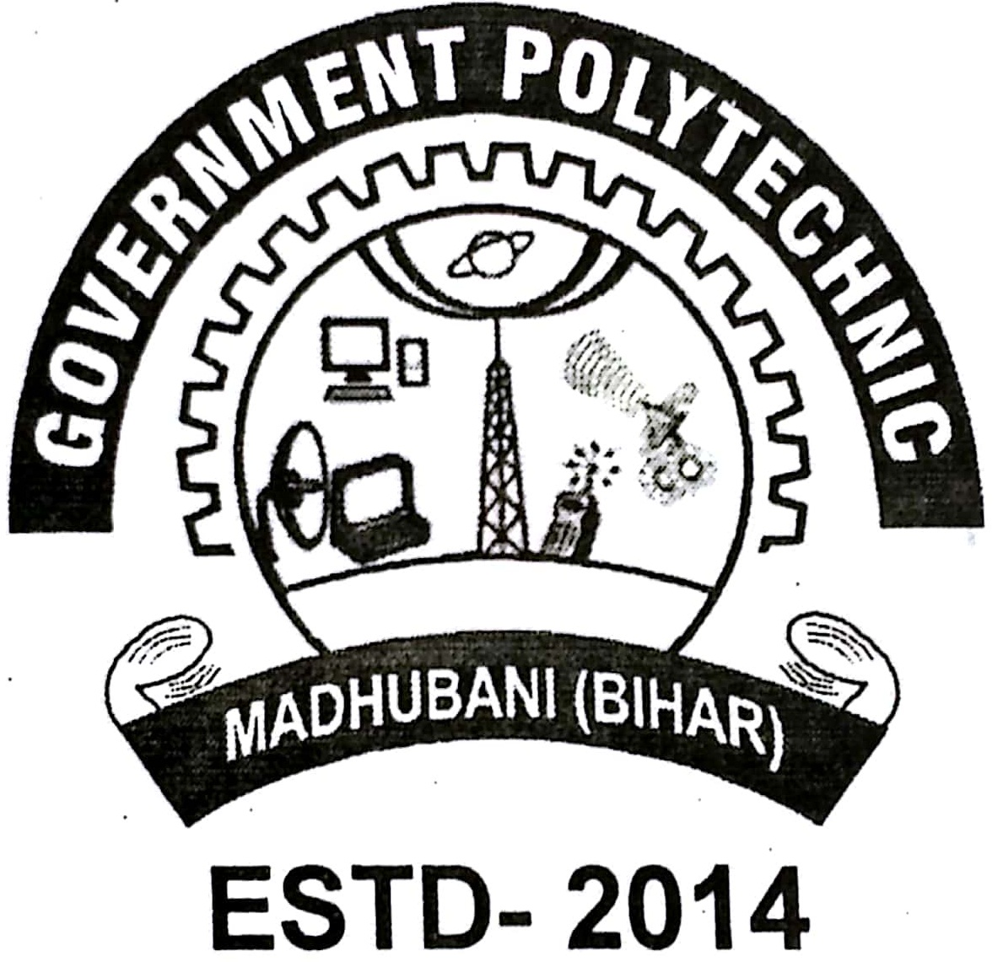
(Principal)
Mob. – +917760742200 Phone- 06273- 291200
E-mail-govpolytechnicmdb@gmail.com

Ref. No. …………………….. /Madhubani Dated ……………………
==================================================================

VACANCY ANNOUNCEMNT
Government Polytechnic Madhubani invites eligible candidates for NATS Trainee for the following departments.
Sl No. | Branch/Department | Qualification | Stipend amount per month (in Rs.)
01. | Library Science | Graduate in Library Science | 15,000
02. | Civil Engineering | B.Tech/ Diploma | 15,000 / 10,000
03. | Computer Science and Engineering | B.Tech/ Diploma | 15,000 / 10,000
04. | Electrical Engineering | B.Tech/ Diploma | 15,000 / 10,000
05. | Electronics Engineering | B.Tech/ Diploma | 15,000 / 10,000
06. | Mechanical Engineering | B.Tech/ Diploma | 15,000 / 10,000

The candidate needs to appear in the walk in interview on 26/07/2024
Reporting Time:- 11am
Venue-Government Polytechnic Madhubani
At-Araria Sangram Po-Tulapatganj Ps-Jhanjharpur 847109
Contact Person:- Mr. Tasgheer Ehsan
Mobile No-9654433601
Note-
- It is mandatory for the candidates to have valid NATS student ID
- Candidates are supposed to come with their CV, one set of Xerox copy of all academic as well as reservation certificate (if applicable) along with valid ID proof and all the original documents for verification.
- Candidate must pass out Degree/diploma in last three year
- There is no provision of TA/DA for interview.
Principal
Govt.Polytechnic Madhubani

